- “construction type” noise levels, construction hours, truck traffic, and staging equipment. The contractor is required to monitor the “tributary levels in the lake during the cleanup process, and they will be required to comply with environmental and community standards.
- What role does the HOA or Lake Tahoma stockholders have during this project?
Lake Tahoma is serving as a liaison between the state and county, the contractor Crowder Gulf, and the Stockholders, ensuring community concerns are communicated and addressed. Mark Ayers, the current President, will serve as the primary point of contact for communication.
- Is this project costing the community anything?
No, this project is being run through a State program called “SMART”, which in turn is reimbursed by the Federal Government. The estimated cost is approximately $70 million.
- How will updates and progress reports be shared with stockholders?
We plan to report monthly to the Stockholders on progress and concerns. As with any project, questions should be directed to Mark Ayers, who will then forward them to the appropriate point person within the State, County, or Crowder Gulf contractor.
- Who will be involved in the communication process and make decisions on this project?
Your current Board will be the final decision-maker on items brought to the Lake Tahoma Community. Nate Harrison will continue to lead the contact with McDowell Emergency Management, and Board President Mark Ayers will remain the primary point of contact for this recovery effort. We will also seek guidance from other Stockholders, such as Knox Tate, who have agreed to assist us in this effort. 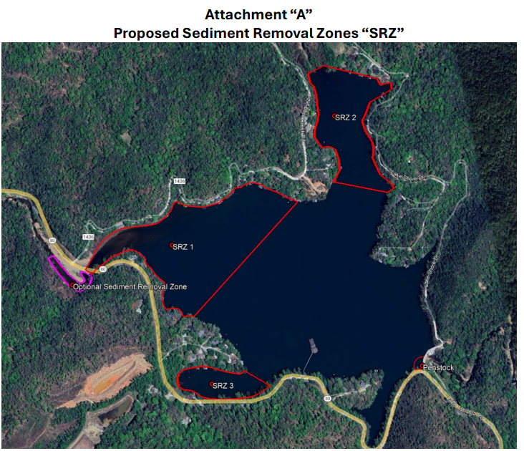
Staging Area

